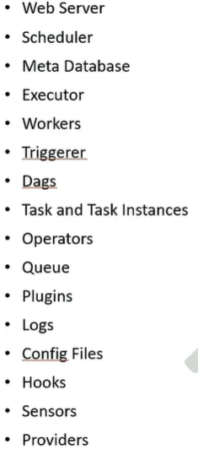
Airflow Data Pipeline Airflow Components
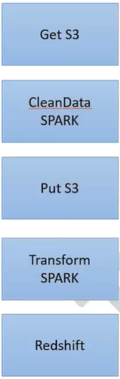

- Web Server:

- Schedular
Interval based scheduling: “0 9 * * *” Sensor Based Scheduling
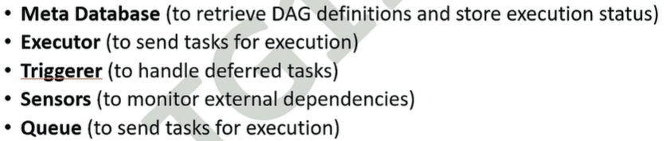
- Matadata Database 4. Executor 5. Trigger 6. Trigger 7. Queue 8. Sensors

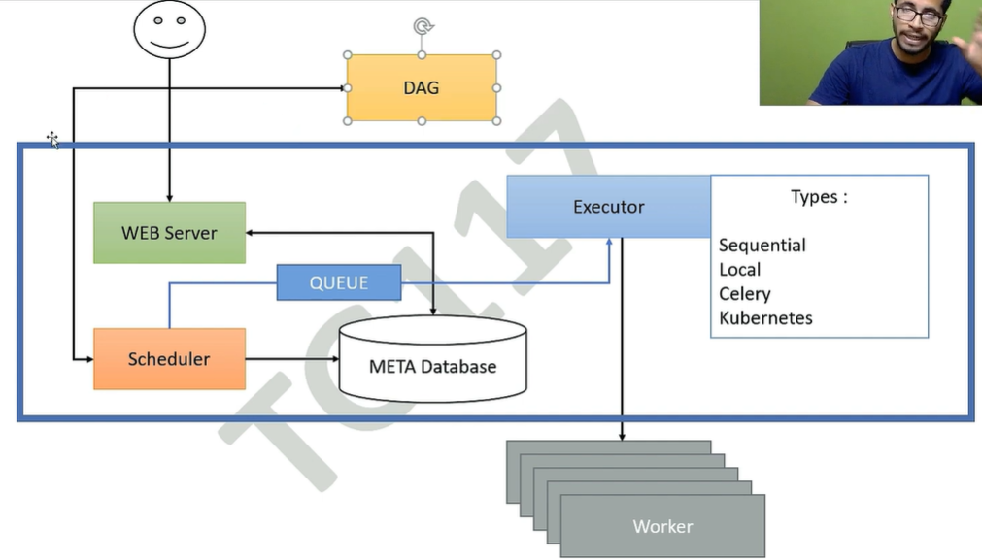

- Worker
- Task and Instance
- Operators:
1. Action Operators
Perform an action
- PythonOperator
- BashOperator
- EmailOperator
2. Transfer Operators
Move data between systems
- S3ToRedshiftOperator
- MySqlToHiveOperator
3. Sensor Operators
Wait for a condition
- FileSensor
- HttpSensor
- S3KeySensor

- Dags
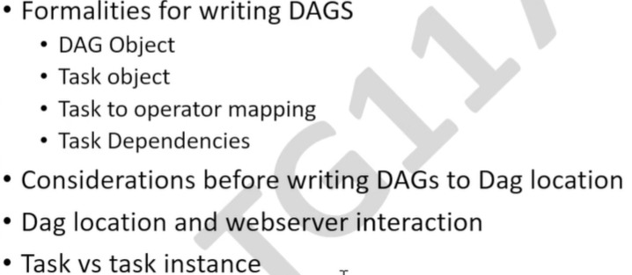

- Plugin
- Logs
- Config Files
- Hooks
- Provider
- Triggerer
- Pool
How many tasks can run at the same time (Capacity management) 128 is default pool
- Queues:
Where does the task run (which worker executes it)

Note: We have two type of task (1) Sequential run -Dependent Task (Frist Run taks1 then 2 and then 3)
(2) If we have a non-dependent then task can be run parallel to

